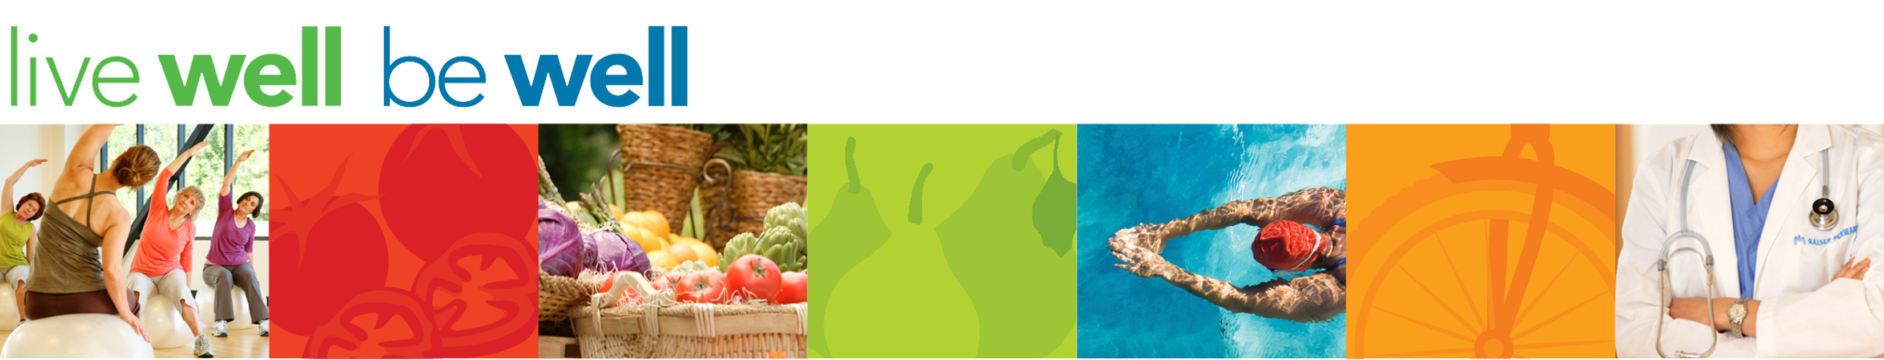

This month’s WOW’s will focus on performing abdominal exercises in the workplace.

Begin by sitting tall in your chair with your feet flat on the ground. Bring one knee up to your chest as high as you can while keeping the chest up and stomach engaged. Hold for 3 seconds and repeat on the other side. Perform 10 repetitions total.



